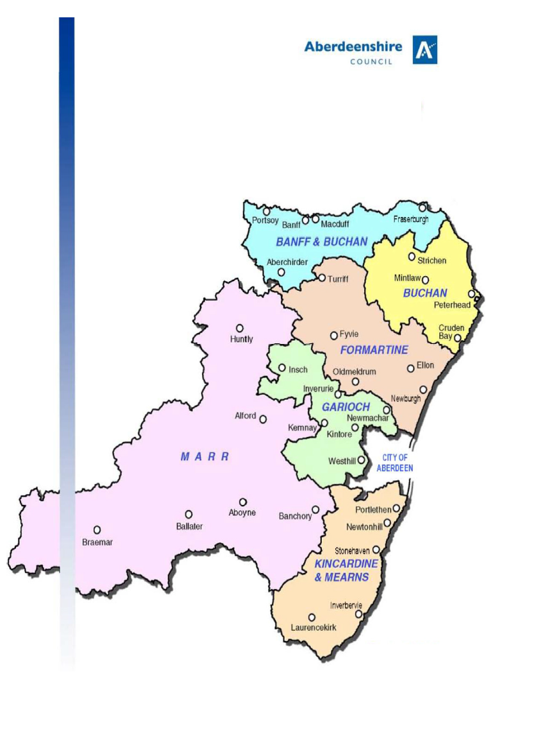

PROFESSIONAL REVIEW AND DEVELOPMENT (PRD) 2014

Revised 2014

PROFESSIONAL REVIEW AND DEVELOPMENT

1 Introduction

1.1 “Professional dialogue within PRD is most effective when it is both supportive and
challenging and signals practical steps towards improved practice. It can help to stimulate and sustain the development of individual teachers as well as helping them to manage the demands of the dynamic contexts in which they work.” (Donaldson 2011)

1.2 The General Teaching Council for Scotland (GTCS) is introducing Professional Update for all fully registered teachers from August 2014. Aberdeenshire Education & Children’s Services PRD is an integral part of the Professional Update. Procedures to be followed by all registered staff can be found in (Appendix 3).

1.3 This document describes the principles and practices of the Professional Review and Development (PRD). It is a process that is intended to be easy to understand and implement. It should lead to increased levels of professional knowledge and skill and subsequently to better learning experiences for the young people in our classrooms, in line with the Aberdeenshire Education & Children’s Services policy for professional learning (Appendix 5).

1.4 Self-evaluation of professional skills and abilities is at the heart of the process. This leads through discussion with the appropriate line manager to the identification of personal and professional needs to be addressed through professional learning.

1.5 The principles of the scheme apply to all professional groups working under Scottish Negotiating Committee for Teachers (SNCT) conditions of service. The document refers to teachers and their professional standards but other professionals should use their own professional standards as appropriate.

1.6 PRD is an ongoing process and shall not be seen just as an annual interview. It is based on “support and challenge” within an atmosphere of trust and collegiality. There is an emphasis on the use of self-evaluation of reviewees and the use of a coaching and mentoring approach by reviewers (Appendix 1).

1.7 Aberdeenshire has an obligation to provide opportunities for teachers to engage in professional learning at individual, establishment and at authority level which are relevant to teachers’ needs, aligned to improvement plans and the GTCS Professional Standards.

2 Aims

2.1 Recognise and celebrate teachers’ personal and professional successes achieved through professional learning.

2.2 Encourage and support further development of both the reflective professional and collegiate working.

2.3 Improve the teaching and learning process through the further development of teachers’ professional knowledge and skills.

2.4 Identify individual and professional development needs, taking account of GTCS Professional Standards, departmental/school improvement plans, the EL&L Service Plan and national and local priorities for education.

2.5 Provide an appropriate structure to support for existing Chartered Teachers and for those who have partially completed the Standard for Chartered Teachers. (Appendix 2).

2.6 To ensure relevant employees meet the requirements of Professional Update.

3 Principles

3.1 The Aberdeenshire Education & Children’s Services process of Professional Review and Development is based on:

- Self-evaluation
- Positive relationships and trust
- Mutual respect and openness
- Observance of appropriate confidentiality
- Provision of resources and funding to support identified professional learning
- Needs at school, cluster, network and authority level

3.2 The head of establishment is responsible for the strategic overview of PRD

3.3 All those involved in the process should ensure roles are understood and carried out effectively.

3.4 The process is an evidence based approach to professional reflection and self-evaluation. The professional dialogue will lead to a shared understanding of development needs.

4 The Process

4.1 The key to the success of the process is effective self-evaluation and high quality professional dialogue between the teacher and the line manager. Teachers should refer to the appropriate professional standards. (Appendix 1).

4.2 All teachers will be involved in the process of Professional Review and Development on an annual basis and will complete and update their Professional Learning Records on MyGTCS (Appendix 3).

4.3 Where the teacher is completing the five yearly Professional Update Declaration they declare their ongoing engagement in the above process to GTCS and their line manager is asked to confirm this.

Step 1
Self Evaluation
Referring to Professional Standards
Annual Update of registration details through MyGTCS.
Appendix 1
Step 3
Agreement of Professional Learning Records
Appendix 3
Step 5
Gather Evidence of Impact
Share with manager / peer colleagues as appropriate.
Step 6
Evaluate and Reflect on Professional Learning Activities

Aberdeenshire Education & Children’s Services
The PRD Cycle

Step 2
PRD Annual Meeting
Identify and agree individual strengths and development needs, ensuring a balance between personal needs and LA / School Improvement Plans.
Step 4
Professional Learning
Undertake a range of appropriate professional learning activities
Appendix 6 & 7
5 Annual Meeting

5.1 The meeting can take place at any time of year.

5.2 After the teacher has completed the self-evaluation process a mutually agreed time will be arranged to meet with the line manager to discuss strengths and possible development needs. Preparation time and meeting time should be set against the two hours allocated within the schools working time agreement. Any additional time for more in depth self-evaluation should be set against the additional 35 hours for professional learning.

5.3 It is emphasised that the self-evaluation process and the meeting between the teacher and the line manager should also be used to identify strengths and it is absolutely appropriate for a teacher to develop further an area in which they have particular expertise.

5.4 The line manager will draw on a variety of evidence sources to assist with discussing priorities and agreement of the teacher’s annual professional learning plan. The sources could include:

- Perceived professional learning needs arising from the agreed school and/or departmental improvement plans e.g. arising from the planned introduction of a new course.
- Outcomes from and the impact of development activities previously undertaken and recorded in the professional learning profile.
- Teacher’s career aspirations
- The need to develop or extend professional knowledge and skills
- Another source would include GTCS Professional Standards

5.5 At the meeting the line manager and teacher will discuss and agree development needs on the basis of available evidence. The line manager will be responsible for ensuring a balance exists between

  - The teacher’s personal needs
  - Local Authority/establishment and faculty/departmental improvement priorities
  - The teacher’s entitlement to continue to develop areas of particular strength/expertise.

6 Outcomes of Meeting

6.1
- Agreement of Professional Learning Record for current session
- Agreement of Professional Learning Plan for coming session
- Every 5 years Professional Update Declaration

6.2 The agreed plan will also indicate where possible how the development needs are to be addressed within available resources. Individual teachers will be able to address some identified needs independently e.g. through e-learning. However, certain needs will require support and/or resourcing.

6.3 The PRD process allows for dialogue and agreement on the contribution that Chartered Teachers will make consistent with the duties of a classroom teacher. (Appendix 2)

7 Implementation

7.1 Over the course of the year the teacher will address the agreed Professional Learning Plan and maintain his/her Professional Learning Record. This process will assist the teacher to prepare for the next annual meeting using MyGTCS Profile. Separate guides are available.

7.2 It is recognised that the plan can be flexible in order to accommodate changing needs that may arise in the course of the year. Any adjustments can be made by agreement.

Appendices

Appendix 1 | Context for Self – Evaluation
Appendix 2 | PRD and Chartered Teachers
Appendix 3 | Professional Update Procedures for Fully Registered Aberdeenshire
Appendix 4 | Professional Review and Development (PRD) and Professional Update – Appeals Process
Appendix 5 | Aberdeenshire Education & Children’s Services Policy for Professional Learning
Appendix 6 | Aberdeenshire Events Website User Guide
Appendix 7 | Aberdeenshire Education & Children’s Services Professional Learning Indicative Plan

APPENDIX 1
Context for Self-Evaluation

For many teachers the appropriate professional standard will be the Standards for Registration. However, some teachers may also wish to refer to The Standard for Career Long Professional Learning and The Standards for Leadership and Management. These standards can be found on the General Teaching Council for Scotland website, at www.gtcs.org.uk. Application of the standard will be different depending on the experience of the teacher and his/her professional and career aspirations. For more experienced teachers the Standard may be interpreted in terms of extending and consolidating the knowledge, skills and dispositions that underpin the Standard. It should be noted that a full self-evaluation against the entire standard is not feasible on an annual basis. It may be that a teacher chooses to self-evaluate against a particular aspect of the standards in any one year as appropriate to their role. Initially it may be beneficial to look at the whole standard.

Possible contexts may include:

- Pre-school
- Inclusion
- Pastoral care
- Additional teaching qualifications
- Professional Recognition/Registration

The Standards for Registration

http://www.gtcs.org.uk/web/Files/the-standards/standards-for-registration-1212.pdf

The Standard for Career Long Professional Learning (CLPL)

http://www.gtcs.org.uk/web/Files/the-standards/standard-for-career-long-professional-learning-1212.pdf

The Standards for Leadership and Management

http://www.gtcs.org.uk/web/Files/the-standards/standards-for-leadership-and-management-1212.pdf

APPENDIX 2

PRD and Chartered Teachers

The SNCT has reached agreement on arrangements for the pay and conditions for existing Chartered Teachers and for those who have partially completed the Standard for Chartered Teachers. This is fully set out in SNCT 12/35 available on the SNCT website under Circulars. It will be included in the revised SNCT Handbook Appendix 2.16) to be updated for August 2014.

It states:

“The SNCT has agreed that pay will be protected at the current point on the Chartered Teacher pay spine for those who are fully chartered and for those who have partially completed the Standard for Chartered Teacher. In return those teachers will make an enhanced contribution to the school or wider educational community. Discussions on the enhanced contribution will continue to form part of the overall PRD process in line with The Role and Enhanced Contribution of Chartered Teachers and Future Pay Arrangements and updated Code of Practice on the Role of the Chartered Teacher”

The PRD process allows for dialogue and agreement on the contribution that Chartered Teachers will make, consistent with the duties of a classroom teacher, in terms of the professional actions contained within the Standards. This Appendix summarises the key aspects in relation to PRD but both the reviewee and the reviewer should make themselves fully aware of:

- The SNCT Code of Practice on the Role of the Chartered Teacher http://www.snct.org.uk/wiki/index.php?title=Appendix_2.16

Enhanced Contribution of CT and those who were working towards the Standard.

The PDRS process provides a means to facilitate dialogue about how Chartered Teachers make a distinctive contribution to the school and education community, taking full cognisance of the professional actions contained in the revised Standard for Chartered teachers under the following headings:

- Educational and social values
- Critical self-evaluation and development
- Impact and evidence of sustained enhanced practice
- Collaboration with, and influence on, colleagues.

The PRD process should record the planned and agreed contribution to be made to the work of the school in the year ahead and should also identify the time and resources required to allow Chartered Teachers to provide an enhanced contribution.

The Chartered Teacher remains a classroom teacher and at no point should the Chartered Teacher be regarded as part of the school’s management structure. Therefore, the contribution which could be made must be consistent with the duties of a teacher as set out in the SNCT Handbook, should maintain the primacy of the teacher’s focus in learning and teaching and must be both realistic and capable of being delivered within the 35 hour working week and a school’s Working Time Agreement. It must also reflect the needs of the school and Chartered Teacher’s own expertise which will take account of their teaching experience, interests, Continuous Professional Development (CPD) and programmes of study undertaken.

Professional Update Procedures for Teachers Aberdeenshire

Appendix 3

Aberdeenshire Professional Update Procedures

Introduction

The General Teaching Council for Scotland (GTCS) is introducing Professional Update for all fully registered teachers from August 2014.

This document sets out the procedures to be followed locally within Aberdeenshire in order to ensure that the requirements of Professional Update are fully met.

Professional Update does not apply to probationer teachers, who hold provisional GTCS registration; it applies only to those who are fully registered with the GTCS.

The key purposes of a system of Professional Update are:

- To maintain and improve the quality of our teachers as outlined in the appropriate professional standard and to enhance the impact they have on pupils’ learning.
- To support, maintain and enhance teachers continued professionalism and the reputation of the teaching profession in Scotland.

The key principles of Professional Update are that the scheme will ensure that teachers have:

- A responsibility to consider their development needs.
- An entitlement to a system of supportive professional development and review (PRD) which can;
- assist them to identify constructive ways to update their skills
- provide access to opportunities which can address those areas identified as requiring support
- help them to manage change
- offer a focus on ways in which they can enhance their careers.

- Confirmation they have maintained the high standards required of a teacher in Scotland’s educational establishments (The Standard for Full Registration is the baseline standard for all fully registered teachers). It is normally attained at the end of the teacher induction scheme but is maintained thereafter throughout a teacher’s career.

- GTCS also recognises the need to ensure that processes are practicable, are supportive of teachers, and not constrained by bureaucracy and allow individual teachers the opportunity to identify and meet their future needs.

Key Stages of Professional Update

Professional Update is a continuous process which contains the following stages:

Stage 1 – An annual update of registration details

All fully registered teachers will be required to check their personal records held by GTCS on an annual basis using the MyGTCS website. Any changes to their circumstances including home address, contact details, employer, school and position held should be updated at this point or at any point during the year when appropriate.

Stage 2 - Active engagement in Professional Review and Development Scheme (PRD)

All fully registered teachers will be required to participate in annual PRD, self-evaluate using appropriate GTCS Professional Standards, engage in professional learning, keep a record of their professional learning and a portfolio of evidence of impact on MyGTCS and discuss the impact of their professional learning with their line manager as part of their PRD.

Stage 3 – Completing a five yearly Professional Update Declaration to the GTCS

All fully registered teachers will be required to complete a declaration every five years confirming that they have actively engaged in an annual PRD process over the previous five years and that they have maintained an up to date portfolio of evidence of the impact of their professional learning. This declaration will be made online, using the MyGTCS website. This will require to be verified by each individual’s PRD reviewer, also using the MyGTCS website.

Roles and Responsibilities

- GTCS will validate Aberdeenshire PRD and that teachers are enabled to demonstrate the skills they already have as well as learn new ones. Much of the work required to operate Professional Update is carried out at Local Authority and school level.

- Teachers are responsible for managing their professional learning and confirming ongoing engagement with the process every five years. Line Managers will play a supportive role, encouraging teachers to reflect on practice with a focus on continuous improvement and assisting in the identification of professional learning activities and opportunities which will contribute towards this.

- The line manager undertaking PRD meetings with their staff has a key role to play in the process. It is anticipated that coaching approaches will be central to the success of professional update. Line managers who carry out the process will be encouraged to develop skills in this area.

- Line managers will be required to confirm ongoing engagement of their staff every five years. It is emphasised that if there is any perceived difficulty in staff not engaging in the process then it should be raised through normal procedures as and when it occurs at any point in the 5 year cycle. It is not envisaged that there will ever be a situation where there is not a “sign off” without a record of action in raising and addressing any perceived lack of engagement by a teacher as and when it occurs.

- Professional Update focus is on continuous improvement. It does not determine whether or not a teacher is, or has remained competent and is entirely separate to any competency procedure. Any such concern about competency must be addressed under the Work Performance Policy and is not part of Professional Update.

Professional Update information by category of teacher

- Teachers on Aberdeenshire Supply list. The Education & Children’s Services will allocate each supply teacher a PRD line manager who will ensure that each teacher will have access to an annual PRD meeting and professional learning.

- Head Teachers will be reviewed and signed off by their line manager e.g. QIO, QIM, Head of Service.

- Central roles. Those who are fully registered but not currently engaged directly in teaching but working in a central role education capacity such as QIOs, seconded staff, etc. Professional Update for such teachers will enable them to confirm their continued understanding of relevant aspects of the Professional Standards and engagement in professional learning. It is not necessary for such teachers to confirm this by active service in the classroom. PRD should continue to be used to record Professional Learning and completion of Professional Update. Where your line manager is not a GTCS registered teacher, there is a facility within MyGTCS to allow them access to sign off.

- Deferral process. There are circumstances which may make engagement in the Professional Update process and completion of the 5 yearly sign-off difficult. These include career breaks, extended periods of illness, maternity/paternity/adoption leave, only occasional supply work. If a teacher is unable to undertake Professional Update sign-off process in the designated year, then a deferral request may be made. An extension to the five year sign-off may be required and in such cases a request for deferral can be made. If the deferral request is successful, it will normally be granted for a period of one year and the teacher would be expected to complete Professional Update sign-off during the following school year.

- The decision to grant a deferral sits with Aberdeenshire in the first instance and a teacher should submit their request to their line manager. The request for deferral should outline the reasons for the proposed deferral and include relevant evidence to support the request. Any decision to decline such a request may be contested through the Grievance procedure. From August 2014 MyGTCS will include a facility to request a deferral from PU sign-off

- The GTCS are in the process of developing further guidance and a related process where it is known that the deferral period will be longer (e.g. an extended career break).

Access to GTCS Records

All fully registered teachers will require to access to MyGTCS through creating an account by completing the following steps:

- Go to the main homepage of the GTCS website:
www.gtcs.org.uk/home/hom.aspx
- Select MyGTCS log-in/sign up from the top right hand corner of the home page.
- Complete and submit the online sign up form.

When first using MyGTCS, the user name and password will be the individual’s GTCS registration number without the forward slash (/), once logged on, they will be asked to create a password which they will use for any subsequent log-ins. Their username will always be their GTCS registration number without the forward slash.

When fully registered employees have made their Professional Update Declaration via MyGTCS, this will be required to be verified by their PRD reviewer. Reviewers can complete this verification by logging into their own MyGTCS account, where they will see details of all colleagues for whom they have responsibility and where they can confirm that the individual(s) concerned has / have fulfilled all of the requirements of Professional Update.

PRD Guidelines

All fully registered teachers should follow the procedures set out in the revised Professional Review and Development (PRD) 2014.

The guidelines can be found on Arcadia and Glow via the links below :

http://arcadialite.aberdeenshire.gov.uk/?p=11455

https://search.glowscotland.org.uk/results.aspx?k=PDRS

The guidelines have been reviewed to ensure that the local PRD fully supports and complements the national Professional Update procedures.

It is essential that all fully registered teachers participate in the PRD procedures on an annual basis to fulfil the requirements of Professional Update and therefore maintain GTCS registration. This includes employees who are not currently classroom / school based (for example centrally deployed employees or secondees) and those working as supply teachers.

Declaration of Employees Professional Update

All GTCS registered employees will be required to undertake stages 1 and 2 above on an annual basis. Stage 3 will be carried out by employees every 5 years. The timing of this 5 yearly cycle will be dependent on an individual’s GTCS registration number (the first two digits relate to the year in which the individual was first registered with the GTCS.)

Participation in the 5 yearly Professional Update Declaration will be as follows:

GTCS Registration year ending in: | Professional Update Declaration to be made in school session
4 or 9 | 2014/15
5 or 0 | 2015/16
6 or 1 | 2017/18
7 or 2 | 2017/18
8 or 3 | 2018/19

Individuals will then continue to complete their declaration every 5 years after their initial declaration. The pilot project which is taking place in
2013/14 will principally involve colleagues whose GTCS registration year ends in 8 or 3 and who have volunteered to take part in the pilot.

Individuals completing their Professional Update for the first time between 2014-15 and 2017–18 will only be expected to confirm that they have participated in annual PRD from 2014-15 onwards, given that Professional Update was not in existence prior to that date. Similarly individuals taking part in the pilot for Professional Update in 2013-14 will only be expected to confirm participation in PRD during school session 2013-14.

In the sign off year the GTC will send a reminder by email to individuals.

Support for Professional Update in Aberdeenshire

Aberdeenshire Education and Children’s Services will oversee the local operation of Professional Update and will provide support to individuals following the procedures.

The support will include:

- Training for reviewees, reviewers and line managers in undertaking PRD and Professional Update meetings (this will be developed as an e-learning package)
- Annual circulars will be sent to all establishments requesting that all GTCS registered teachers are reminded regarding the need to check and update their personal GTCS records at the beginning of each session. This will also be circulated to teachers on Aberdeenshire Supply List and those fully registered teachers undertaking central roles.
- For those individuals due to complete their Professional Update Declaration a reminder will be sent in the appropriate year.
- Direct contact will be made with those individuals who have not completed their annual records update and / or Professional Update Declaration by the stated deadline to offer support and advice to ensure these tasks are complete
- A quality assurance process is being developed to affirm that the teacher entitlement is being met.

APPENDIX 4

Aberdeenshire Education & Children’s Services

Professional Development Review Scheme (PDRS)
and Professional Update

Appeals Process

Appeals

- Mediation Process

If agreement between the reviewee and his / her reviewer cannot be reached, then the following steps should be taken in the order given:

Step 1:
The reviewee should meet again with his / her line manager in an attempt to reach consensus and be able to ‘sign off’ the documentation.

Step 2:
If Step 1 is unsuccessful, the reviewee should appeal to the reviewer’s line manager who will discuss the matter with both parties and seek a resolution.

Step 3:
If Step 2 is unsuccessful, the matter will be referred to the Head Teacher, or, where the Head Teacher has already been involved the relevant Quality Improvement Officer.

Step 4:
The right of appeal for a Head Teacher or centrally based employee will be to the appropriate Head of Service / Director.

Step 5:
The final right of appeal and final arbitration would be LNCT Joint Secretaries

- Appeal against the procedures not being followed correctly

The reviewer and reviewee will have recourse to the Service’s grievance procedures.
Education & Children’s Services


ABERDEENSHIRE EDUCATION & CHILDREN’S SERVICES
POLICY FOR PROFESSIONAL LEARNING (CPD)
Our aspiration is that the Education & Children’s Services should be one in
which everyone is learning together.
Rationale
Education & Children’s Services is committed to the provision of regular and high quality professional learning for its entire staff as an entitlement. This is central to the quality of the service and the process of continuous improvement. Such a commitment is necessary to meet statutory and non – statutory needs as well as individual needs arising from the Professional Review and Development (PRD), the Employee Annual Review (EAR) and Chief Officer Appraisal (COA). It is also reflected in improvement planning and resource allocation. Professional learning refers to professional development in the broadest possible sense.
For all Education & Children’s Services staff, this is based around the same cycle; self-evaluation at individual and establishment / service level, planning for improvement, finding appropriate opportunities and assessing the impact of the professional learning that has taken place.

Revised July 2014
Professional Learning Cycle

Self-evaluation forms the basis of establishing what staff and the service needs from professional learning. Self-evaluation is not a bureaucratic or mechanistic process. It is a reflective professional process through which staff and learning communities get to know themselves well and identify the best way forward for their service users.
Self-evaluation processes should be organic and be embedded within daily practice; however, there will be significant areas of professional development that may require a more structured approach.
In the cycle of self-evaluation and planning for improvement, questions which the individual or learning community should consider include:
Reflection
What are my strengths and development needs? What do I want to improve? What Professional Learning will help me improve my practice?
Planning
How will I learn? What outcomes and impact do I expect from my professional learning? How does this articulate with the identified priorities of the Education & Children’s Services ? What will I do now?
Learning
How will I learn? What resources are available? How can I collaborate with others?
Evaluating Impact
What impact has my learning had on my practice? What impact has it had on service users? How do I know?
Reflection
Planning
Evaluating Impact
Learning
It is not intended that every member of staff or learning community will apply each stage of this process for every professional learning opportunity. Some opportunities are spontaneous and experiential; however, an awareness of this self-evaluation and planning cycle will create a helpful mindset in thinking about professional development.
This professional learning cycle will support the formal PRD/EAR/COA and improvement planning process and also any other consideration of significant professional learning opportunities.
Supporting Professional Learning
What do we already know about effective professional learning?
It is understood that effective professional learning is much more than attendance at courses or other such events. Increasingly, staff are seeking professional development through collaborative work, action learning, professional learning communities, peer support, mentoring, coaching, professional reading, secondments and other practice based activity.
Key features of effective professional learning are:
It should be ongoing, as part of a planned process.
It should be directly relevant to the participants, taking account of previous knowledge and expertise.
It should recognise the need to support succession planning.
It should have clearly defined intended outcomes.
It is based on the best available evidence about professional practice and where appropriate, facilitated by people with the necessary knowledge and skills.
It will include the introduction of new knowledge and skills. Effective professional learning may also promote and embed continuous enquiry and problem solving, coaching, collaboration, modelling and experimentation.
It should include reflection and evaluation of impact and outcomes as part of the activity from the outset.
Use of Outside Providers for Professional Learning Outside Providers
When considering commissioning external providers, please discuss and seek further guidance from appropriate Officers within Education & Children’s Services.

Evaluating Impact of professional learning
Key features of effective evaluation of professional learning are:

It should lead to improved future professional learning

It should inform improved outcomes for service users

It should focus on what participants learn, how they use what they have learned, and the effect on service users

It should be undertaken within agreed timescale for evaluating outcomes, accepting that some outcomes, such as children and young people’s improved performance may take longer to become evident than others/ Unanticipated outcomes will also be important.

Where appropriate, it should be a collaborative process. It should be undertaken using agreed evidence and success criteria and be proportional to context.

It should be considered in the short, medium and long term. Extended professional learning activities should involve evaluation of impact at agreed stages.

It should consider best value.

It should inform future learning and practice for individuals and learning communities.
Aberdeenshire Education & Children’s Services Professional Learning Calendar

In order to directly support individuals, establishments, clusters and authority staff, professional learning needs information has to be gathered on an annual basis.
The timing of this needs analysis conforms with the cycle of improvement planning and self-evaluation. This will allow the planning of a programme of professional learning, which is aligned to the identified development needs across the service and which will maximise the use of key dates and personnel.

August | In-service
September | Service plans completed and circulated. Establishment S&Q reports submitted.
October
November | In-service
December
January | Begin process of identifying improvement priorities for the year
February | In-service
March
April
May | Service wide Professional Learning Needs Analysis for the following year due for completion.
June | Service Professional Learning Indicative Plan circulated
July

In conjunction with this plan, individuals, establishments, clusters/networks and groups of staff will have a concurrent programme of professional learning undertaken at appropriate times and in line with national agreements.

Link to Professional Learning Information
Aberdeenshire Events Website CPD Find
Aberdeenshire CPD Glow Group Learning and Development Corporate Leadership
Service Plan

 Aberdeenshire CPD Appendix 6
Using Aberdeenshire Events Website V6

Aberdeenshire Events User’s Guide
The Aberdeenshire Events Website is the only way to book onto events organised by Education & Children’s Services and covers all training, seminars & conferences. Each individual must book their own place on an event. Staff should not book places for anyone else, nor should they indicate in the comments field that multiple places are required for a group of staff.

This guide will show how to:

- Access Aberdeenshire Events
- Create an account
- Register for an event
- Contact us
- Get further help

Access Aberdeenshire Events
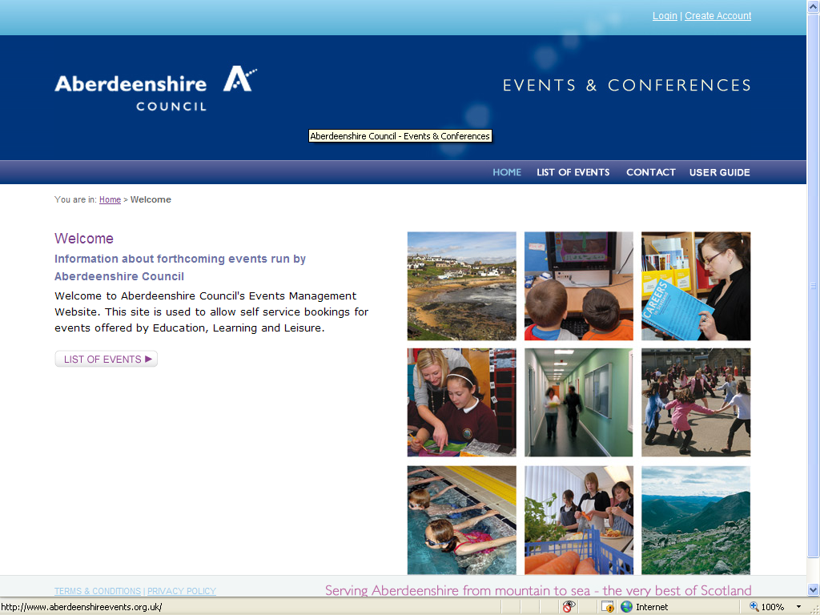
To access the Aberdeenshire events website, you can follow this link or copy the URL and paste into your internet browser:

www.aberdeenshireevents.org.uk
(why not save it as a favourite)

The home page will now be displayed

If you are new to the system and want to register for an event for the first time, you will need to create an account:

Creating an Account

Click on the ‘create account’ section at the top right hand side of the screen (on pale blue bar) and you will see this screen.

1. Enter your e-mail address (ensure that this is an e-mail which you access regularly – as any updates and event information will be sent to this e-mail address)
2. Confirm your e-mail address.
3. Create a password – any memorable word with 6 characters or more.
4. Confirm the password.
5. Enter personal details as directed.

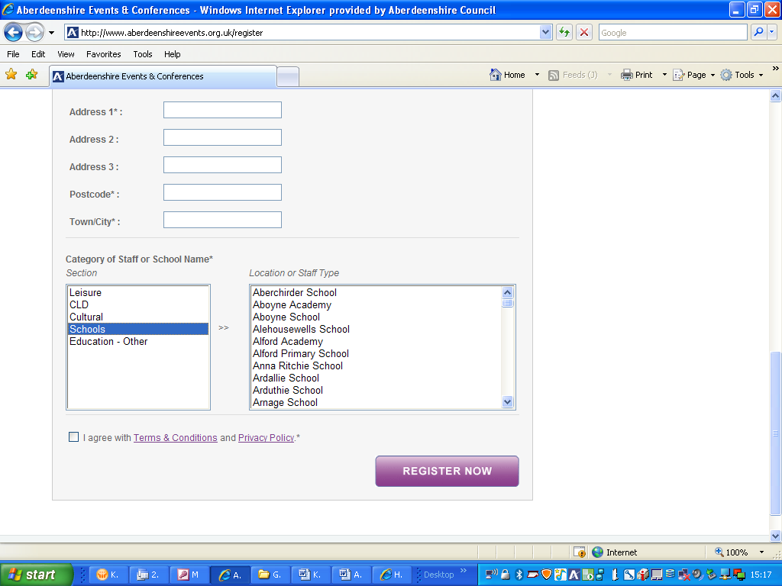
Select ‘Category of staff or school name’ (all teaching staff should select School, then choose their own school from the ‘Location or Staff type’ box. .

Visiting specialists should select: Education Other (as they are not members of staff at a particular school), the choose ‘ aa Visiting Specialist teacher (regardless of base) from the ‘Location or Staff type’ box. Similar for EPS, Sensory Support, EAL etc

Ensure that you click a √ into the box:
Click ‘Register Now’ 

You will now be asked to check you details and confirm if they are correct: -


If these details are all correct, click on



Next you will see a screen which will tell you to check your e-mail.


An e-mail will be automatically generated from the website to your e-mail account which you have signed up with. You may need to check in your spam box depending on your e-mail settings; however the e-mail should only take a few minutes to come through. You will receive an e-mail from Aberdeenshire Council and the subject will be ‘confirm your e-mail address’ sample below:

- Dear
Thank you for registering with the Aberdeenshire Events and Conferences website.
To activate your account please click on the following link:
http://www.aberdeenshireevents.org.uk/register/validate_email/75b70bad4f019a92ca7d83ec490447fd
If you have any questions, not covered by the FAQ document located in the Related Documents area, please contact us using the details below or once logged in, use the contact form within the website.
Regards,

You MUST click on the link or you will not have an active account.

Once you click on the link, you will be invited to log into the account and you will be able to start booking events. You will also receive an auto generated email telling you that your account has been activated.

Booking an event

To view the list of events, click on: List of events. These can be sorted in event number order, date order or closing date order by clicking on the headings.

Select the event which you wish to attend
(Click on to view

more information).

Click on button

Now Log in using the E-mail address and password which you created and click ‘Login’
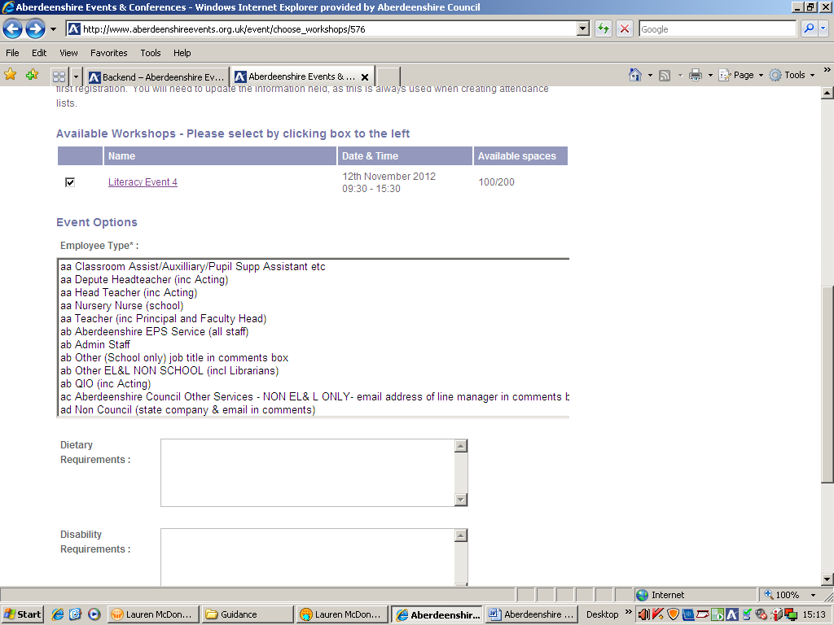
Remember to place a √ inside the small box next to the name of the workshop(s) you wish to attend.
Select your employee type from this section.
Place any dietary / disability requirements and other comments in the appropriate boxes – if there are none – then simply leave blank.
Now click

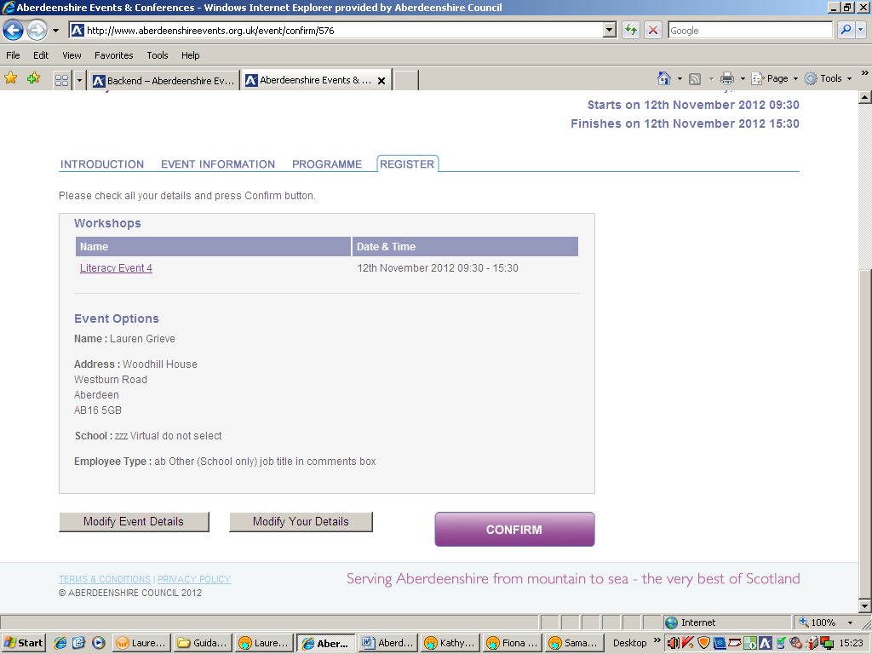

This screen is for you to check your details and confirm once you are happy they are correct. If you have made a mistake in booking – you can ‘Modify event details’ or if you have noticed that there is a mistake in your own details you can ‘modify your details’. If you are happy to continue click

Note: if you have changed school or job since you last used the site you MUST change your own personal details or you will not receive any confirmations to attend events.

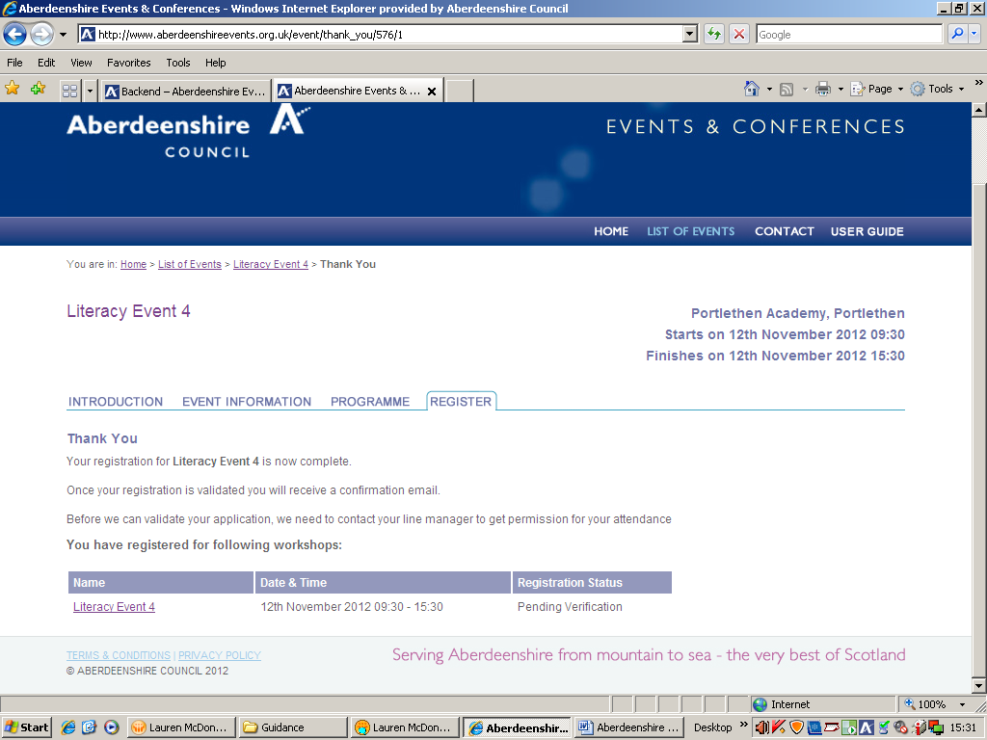
The final screen will thank you for registering for the event.

Your ‘registration status’ will say ‘pending verification’ at this point of the process – this is quite normal.

This will change to ‘verified’ once we have sent out confirmation emails after the closing date.
Please do not concern yourselves with ticks and crosses; these are for our use only
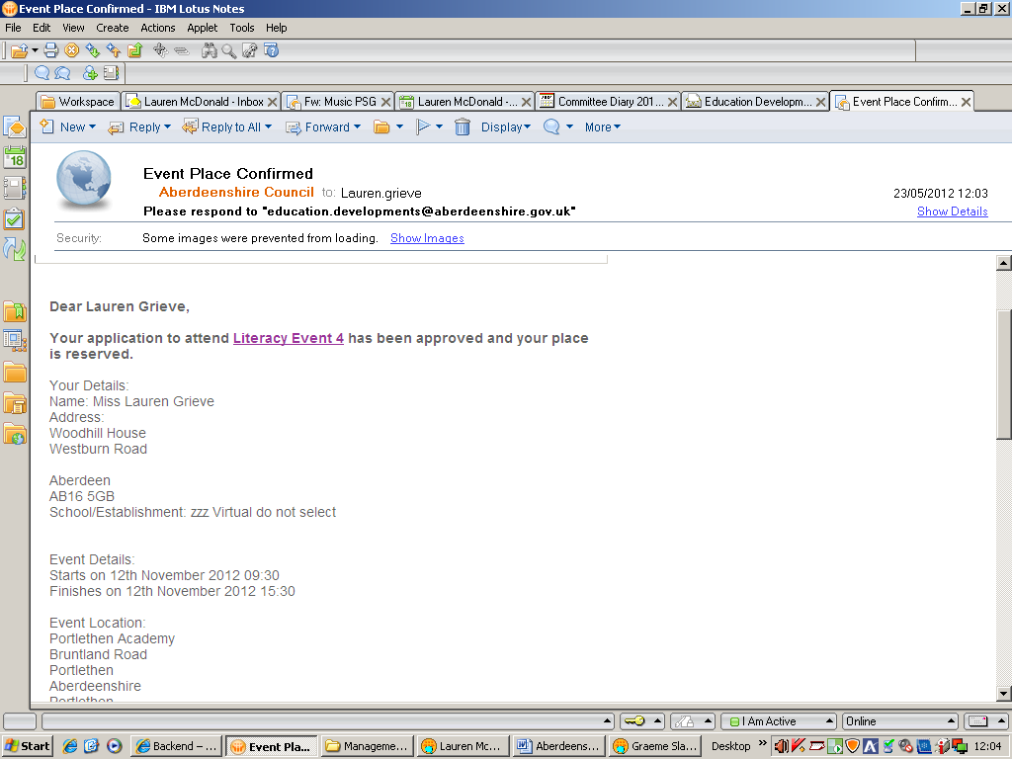

Confirmation e-mails’ are usually sent out after the closing date of an event.

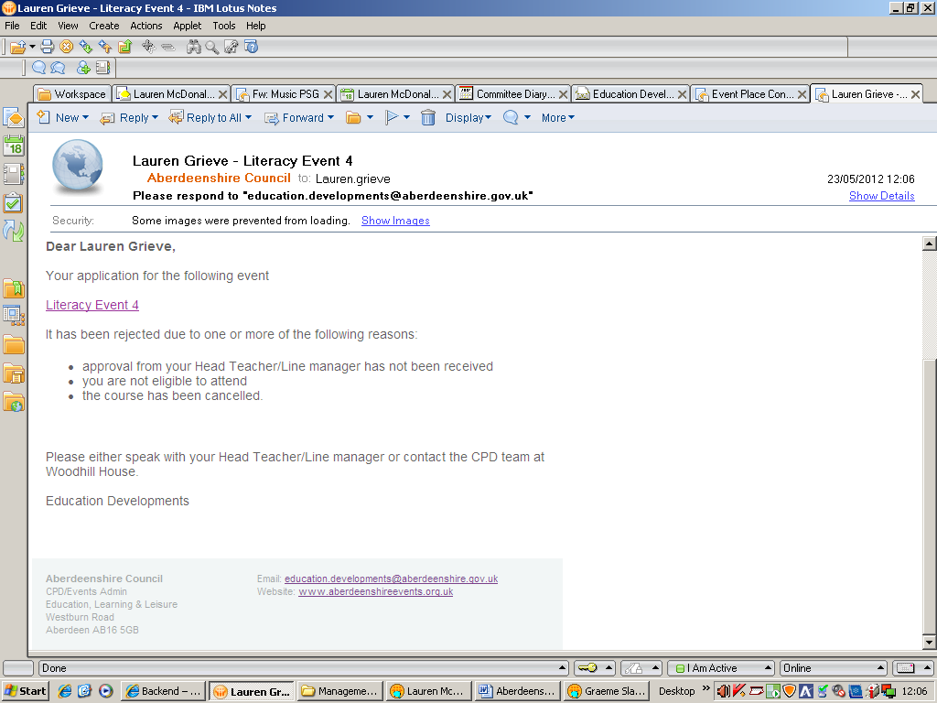
The ‘Rejection’ e-mail will look like this:

There could be 3 reasons for receiving a ‘rejection’ e-mail. The main reason is usually that your Line Manager has refused permission for you to attend.


To get further help

Click on User Guide on the website

Contact us:

You can click on ‘contact’ which will take you to this screen:
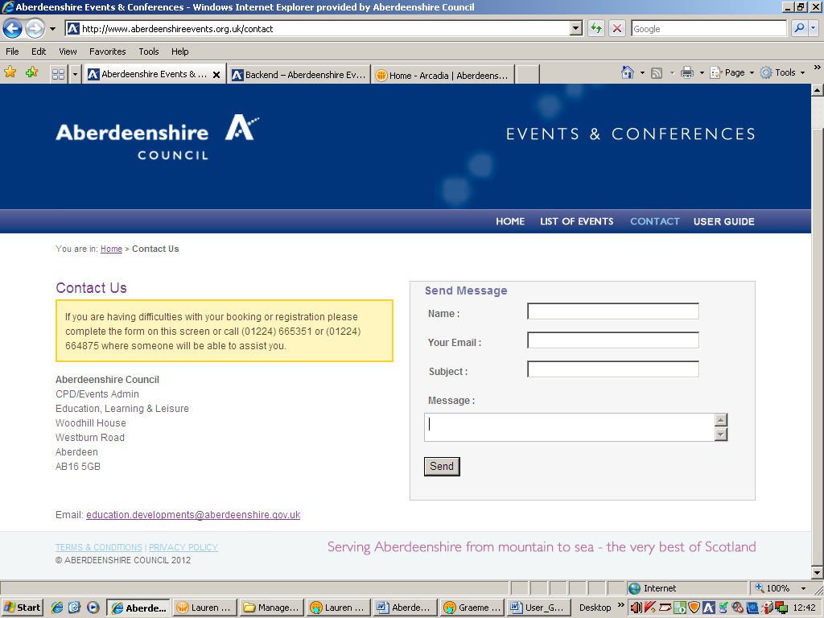
You can use this screen to send us a message by typing in your name, e-mail address, subject and specific details of the problem you are encountering and click on send. Alternatively you can

Contact us: by e-mail:
education.developments@aberdeenshire.gov.uk
Or by telephone to 01224 665351 01224 664875

Top Tips
1. Events are listed and sent out in the weekly school mail email.
2. Make sure you book before the closing date as additions cannot be made after this.
3. Login and click on Your Account top right hand corner. This will show all the events you have registered for and your current status for each (useful if you are unsure if you have signed up for an event or not)
4. Make sure you have selected the correct school or establishment when you create your account. Permission requests will only go to the school you have indicated. If this is not correct, they will not reach your line manager and you will not receive confirmations that you are able to attend.
5. Similar to 4 above, make sure you change your school or establishment if you move to a different job.
6. You should not just ‘turn up’ to an event that you have forgotten to sign up to.

Weekly Newsletter Option

There is a new function on the Aberdeenshire events website which will enable the user to receive weekly e-mail updates.

The updates will include any new training opportunities which have been added to the site and any amendments to current training opportunities.

To subscribe to this new function, please follow these steps:

- Open your internet browser and go to the site:
www.aberdeenshireevents.org.uk

- Log onto your account by using your registered e-mail address and password.

- Click on ‘Personal Details’

- Scroll down to the bottom of the page

- Tick event newsletter box

- Click Update Button.

Your screen should look like the below screen shot.

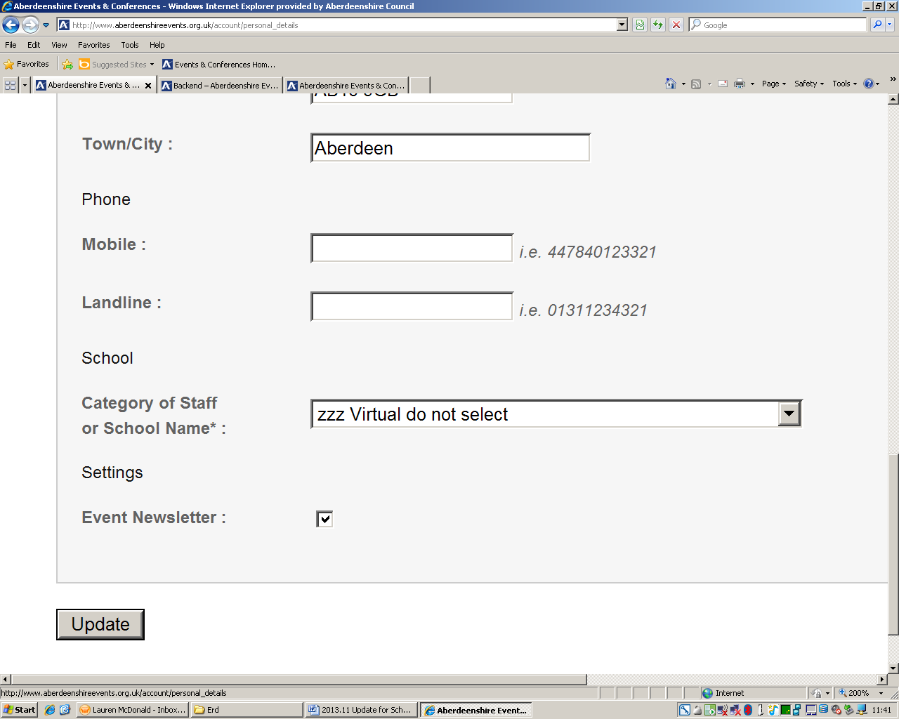

You will now start receiving regular Aberdeenshire events updates.

You can un-subscribe at any time by repeating the above steps and un-checking the box.

Appendix 7

Aberdeenshire Education & Children’s Services
Professional Learning Indicative Plan 2014/15

Professional Learning Indicative Plan 2014/15 is currently being developed.

