APPENDIX
ADJUSTING YOUR WORKSTATION TO SUIT YOUR NEEDS

(a) EQUIPMENT
Your workstation should give you a number of adjustable features. You should adapt all of its components to your own body, to give yourself maximum comfort and support.
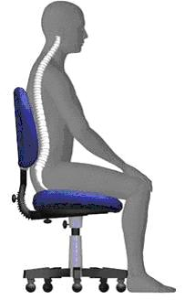
● Chair
The chair should be stable and allow the user easy movement. Ideally the chair will have a five-footed base with castors and a swivel seat for comfort
The seat height should be adjustable as well as the seat back and tilt. As a general guide, once you have found a comfortable position, your eyes should be level with the top of the screen and your arms should be approximately horizontal
Adjust the chair height to ensure hands are horizontal to the keyboard
Once the chair has been set to the correct height if your feet cannot be placed flat on the floor then a footrest is required
The chair’s back rest should be adjusted in height and tilt so you can get good lumbar support to the lower part of the back.
Make sure that the seat cushion is not too long for you - you must be able to sit fully back in the seat so that your pelvis takes the weight
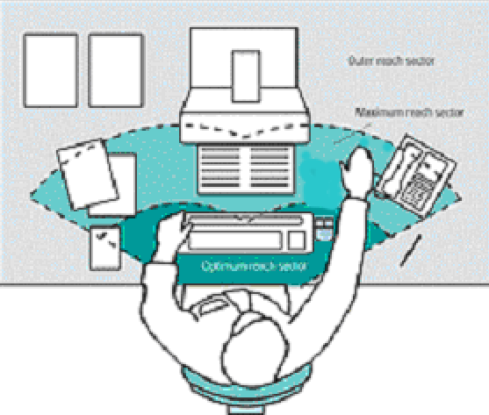
● Desk
The work desk or work surface shall have a sufficiently large, low-reflectance surface and allow a flexible arrangement of the screen, keyboard, documents and related equipment
The document holder shall be stable and adjustable and shall be positioned so as to minimise the need for uncomfortable head and eye movements.
There shall be adequate space for users to find a comfortable position.
There should be sufficient space under the desk to move legs freely. Move any obstacles such as boxes or equipment
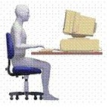
● Display Screen / Monitor
As a general guide, the screen should be positioned about
35cm-60cm away from you or about an arm’s length.
By sitting ‘face-on’ to the computer screen, you will avoid having to twist the body placing unnecessary strain on muscles and tendons.
The top of the screen should be level with your eyes. The screen should be tilted back slightly, so that its surface is at the correct angle to your line of slight.
The desk and screen should be arranged so that bright lights are not reflected on the screen. For example you should not be directly facing windows or bright lights. Ideally your screen should be situated at a 90-degree angle to the source of reflection / glare.
● Keyboard
The keyboard shall be tiltable and separate from the screen so as to allow the user to find a comfortable working position avoiding fatigue in the arms or hands.

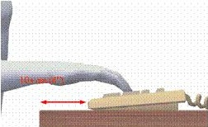
You should have approximately 10cm (4 inches) of clear room in front of your keyboard to rest your wrists during pauses in work, when you are not keying
Try to avoid stretching your fingers and twisting your wrists
Be gentle, use a soft keying action – do not ‘pound’ the keyboard
Don’t lean your wrists or forearms on the desk when using the keyboard this puts direct pressure on the wrists. If you rest your wrists whilst inputting get a wrist support
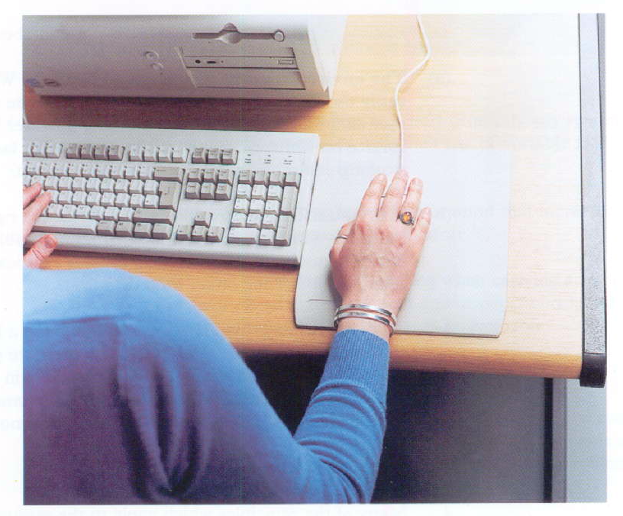
● Mouse
Place the mouse or input device so that your forearm is supported and your wrist straight whilst you use it. Make sure it is as close to your body as possible. You should not have to stretch to reach the mouse.
If continuous use of mouse is necessary, the keyboard should be moved to the side and the mouse placed directly in front of the user.
● Laptop
Laptops should not be used for extended periods and are not suitable as regular workstation unless provided with the appropriate equipment.
For example an external keyboard and mouse allowing separation of the keyboard and laptop screen, the laptop can then be placed on a laptop stand to raise the screen to the recommended height. Alternatively, a docking station can be acquired then the laptop can be plugged into the docking station and used as the hard drive however a separate keyboard, mouse, monitor are required.

(b) ENVIRONMENT
● Space
The workstation should be dimensioned and designed so as to provide sufficient space for the user to change position and vary movements.
Whether you are working at a base location or at home the most common accidents are slips, trips and falls. Therefore you should repair, replace torn carpets or floor coverings, quickly clean up spillages, ensure stairs and corridors are well lit.
● Temperature, Humidity and Ventilation
Office environment should be no lower than 16 degrees although individuals have different tolerances. There is no official upper limit in terms of temperatures in indoor workplaces however the World Health Organisation (WHO) recommends that the maximum air temperature for working in comfort should be 25ºC
Humidity of the office should be maintained at a comfortable level to the user. Recommended levels are between 40% and 70%. Excessive humidity can be unpleasant and extremely dry air can cause discomfort to DSE Users
● Lighting
The way the workplace is lit can also cause problems. According to research, natural light tends to be preferable to artificial lighting. So, as far as possible, all lighting at work should be natural. This can be achieved by using windows or skylights.
If that is not possible, all lighting must be sufficient so that work can be carried out safely and without causing eyestrain.
The lighting recommendations at computer workstations should be between 250-450 Lux.
Poor office lighting can also cause people to slip, trip or fall. Therefore, corridors and stairwells should be well lit, but not so brightly as to distract people from obvious dangers and risks.
● Noise
The noise level at the workstation should not be sufficiently high to prevent you from being able to concentrate and carry out work. For example, you should be able to carry out a work-related conversation or hold a telephone conversation without being significantly affected by background noise.
Noisy office equipment such as printers or photocopiers may need to be relocated away from the office occupants or separated by screens to limit noise
● Software (interface between computer and operator / user)
Software must be suitable for the task
Software must be easy to use and, where appropriate, adaptable to the level of knowledge or experience of the operator or user

e) MANUAL HANDLING – LAPTOPS AND ACCESSORIES
Where employees have to carry their equipment around with them, they are at increased risk of manual handling injuries such as strains to the back, neck and shoulder. Laptops and accessorises (mouse, keyboard, laptop stand, power leads etc.) are typically in excess of 5kg. Although well within the ‘accepted normal load’, they may need to be carried in addition to other items when working remotely between home and office or base location.
Reducing manual handling injuries
● Always try to reduce the amount of weight in your laptop case
● Do not carry equipment or papers unless they are really likely to be needed
● Minimise the hard copy documents you take. Store them electronically on the laptop or on a disk / memory stick
● Consider use a backpack / rucksack to cut down on strain on arms and distribute loads evenly across the body. This is also less conspicuous for personal safety reasons. Alternative, use wheeled luggage where possible and appropriate
(g) PERSONAL SAFETY
There is also a real risk of theft and steps should be taken to avoid personal injury by being cautions whilst carrying or using your laptop, mobile phone or blackberry. Take sensible precautions such as:
● Plan your tasks to avoid situations where you are likely to be working in circumstances where theft is likely
● Take extra care in public places, or in other situations (or at times) where either risk of theft may be greater
● Always be conscious of vehicle security when transporting your laptop, mobile and / or blackberry between venues e.g. never leave it in view in an unattended vehicle; never leave it overnight in an unattended vehicle
CORRECT POSTURE
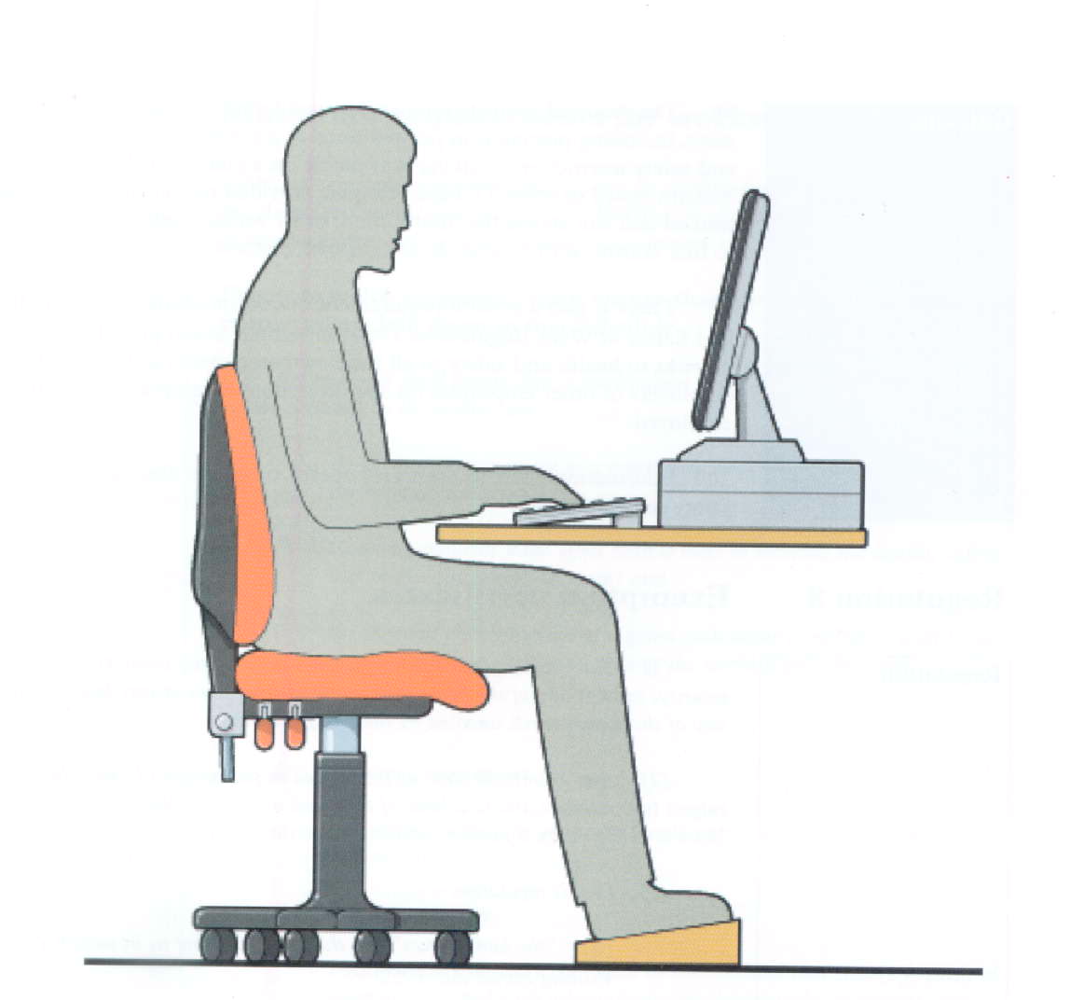
Seat:
level with knees
Back:
upright and straight
Elbow:
90º angle
Knee:
90º angle
Feet:
flat on floor –
or on footrest
Eyes:
Level with top of screen

FIGURE 1 - SEATING AND POSTURE FOR TYPICAL OFFICE TASKS
❖ Seat back adjustable
❖ Good lumbar support
❖ Seat height adjustable
❖ No excessive pressure on underside of thighs and backs of knees
❖ Foot support if needed
❖ Space for postural change, no obstruction under desk
❖ Forearms approximately horizontal
❖ Wrists not excessively bent (up, down or sideways)
❖ Screen height and angle to allow comfortable head position. Screen position about 35cm-60cm
away from you or about arm’s length
❖ Space in front of keyboard to support hands/wrists during pauses in keying (approx 10cm (4inches)

