Management of Aberdeenshire Council Housing Stock in relation to bats
March 2018

To be read in conjunction with SNH “Works Affecting Bats Licence” March 2018-October 2019

- Scope:
The SNH Works Affecting Bats licence covers the following: -

- Housing Improvement Programme (HIP) upgrade works, as well as maintenance and repair activities to the Council’s housing stock, both of properties classified by Aberdeenshire Council (desk based assessment) as Negligible Roost Potential and classified as Low Roost Potential following External Preliminary Roost Assessment (PRA) undertaken by a licenced bat surveyor.
- Works to properties classified by PRA as having Moderate Potential where activity survey has confirmed fewer than 5 bats of licenced species are present.

This licence does not cover: -
- Works to all Aberdeenshire Council sheltered housing complexes.
- Works to properties containing known roosts.
- Works to properties classified as having Moderate roost potential by PRA which, following activity survey, have been found to have a roost of more than 5 bats.
- Works to properties classified as High roost potential following PRA.

- Tool Box talks
Tool box talks (appendix C) for all operatives working on the properties covered by the Licence to be provided annually and should include the following topics:

  - Pre-works inspection – staff should be aware of typical bat signs they should look out for i.e., droppings, smell that could indicate signs of bat use. A check of the work area should be carried out before works begin. Signs of heavy use that could indicate presence of a larger roost should initiate a visit from a licenced bat surveyor.

  - For categories of work listed below all operatives will work in a bat sensitive manner. When carrying out works on areas where it is thought bats may be present staff should carry out a soft-strip i.e. by-hand using hand tools (when material requires stripping), checking material for bats before discarding.
Works: -
External Wall Insulation
Roof cover replacement
Roof light removal or replacement
Dormers (pitching of flat roofs)
Porches (pitching of flat roofs)
Photovoltaic Roof Panels (PVs)

  - For Internal Works - If bats are found during internal works (kitchen replacement for example) to any housing property work should stop immediately and Environment Planners/SNH should be contacted for advice on how to proceed. Note that properties with roost potential do not require a PRA or activity survey prior to internal works commencing.

  - Finding bats less than 5 bats whilst working – staff should know what to do if small numbers of bats (less than 5) are encountered during works (i.e. bats to be transferred to suitable vessel containing air holes, a small shallow dish of water and some form of cover such as a clean cloth – this should be done by someone wearing suitable gloves – bat/s should be kept in container until dusk when it can be placed on a raised area allowing bats to safely disperse). The equipment needed to perform this task must be kept on site ready for immediate use. Please see further guidance – appendix A. If more that 5 bats are found see 4 below.

  - When to immediately stop work and contact Aberdeenshire Environment Planners for advice – 1) if bats are found during works at a time of year when bats would normally be hibernating (December to February inclusive, though this could be extended in either direction if weather has been particularly cold) or 2) a roost site containing more than five bats is uncovered 3) if juvenile bats are found (bats that do not have a furry body). Aberdeenshire Environment Planners will advise on immediate action and on contacting a licenced bat surveyor and or SNH as required

  - Understanding bats and the law – what the licence covers should be clearly explained. Also it should be made clear that not adhering to conditions of a licence can lead to offences being committed. Where there is confusion contact numbers for relevant Aberdeenshire Council/SNH licensing contacts should be available.

- Bat enhancement features

  - Aberdeenshire Council, in conjunction with a suitably qualified licenced bat surveyor, will install and monitor external bat boxes at six buildings where it is thought there is a good chance of bat use. External artificial roosts will be low profile Schwegler type boxes (see Appendix B) in a range of low profile styles with 3 boxes at each of 6 locations on suitable aspects of the buildings chosen. Locations will be areas where there have historically been bat roosts and/or bat activity and where surrounding habitat and habitat linkage is suitable. Boxes will be monitored annually and consideration will be given to moving/relocating boxes with no uptake after 2 seasons.

  - Artificial bat roosts should be monitored by bat activity survey by licenced bat surveyor once per year during the peak activity period for bats (June – August).

  - Every effort will be made to secure additional internal provision at new build housing schemes as these are developed.

- Checklist/kit list for on the ground staff

- Access to useful contact numbers (Aberdeenshire council, SNH licensing helpline) see Appendix C.
- Access to bat storing container and accessories e.g. gloves.
- Aide memoire on bats/bat signs.
- Access to copy of licence.

Appendix A

Basic bat care – for bats found during works – following advice from BCT web site.
To handle any bat WEAR GLOVES due to the small risk of a type of rabies.
To contain a bat you will need:
- A shoe box, with holes punched in the lid (or container of equivalent size)
- A cloth or teatowel
- A plastic bottle cap (milk bottle tops are perfect)
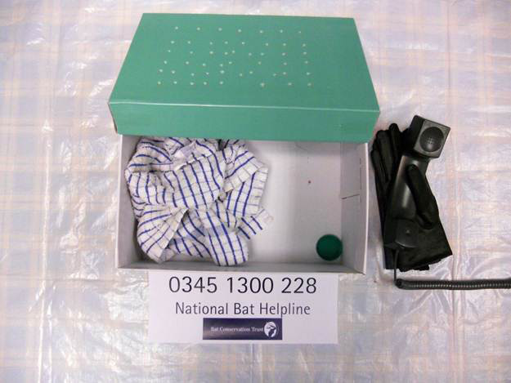

How to contain the bat:
1. Contain the bat:
a) Like a spider, by placing a box on top of it and sliding a piece of card underneath.
b) Alternatively, cover the bat with a cloth/teatowel and carefully scoop it up and place it in the box. (You should not handle the bat with bare hands.)
2. Put a tea towel or soft cloth in the box for the bat to hide in.
3. Put in a small, shallow container e.g. a plastic milk bottle top with a few drops of water (not enough for the bat to drown in). Make sure the water is topped up regularly.
4. Keep the bat indoors somewhere quiet and dark.
5. Place the container on a raised area outside at dusk to allow the bat to disperse (remove the lid). A bat should never be released during the day and should only be release if fit and healthy.
6. If you think the bat is injured in anyway call the Bat Conservation Trust Bat Helpline on 0345 1300 228 for further advice and a bat rehabilitator will be able to advise.
Appendix B
1FQ Schwedler Bat Roost (For External Walls) or similar type of box to be used for enhancement
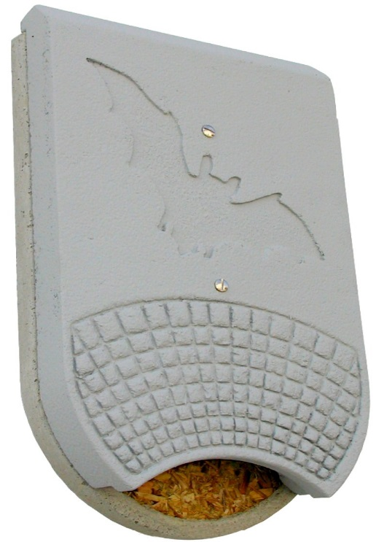

Appendix C - Supporting Documents

- Aberdeenshire Council - Guidance for Officers – Bats Our Legal Responsibilities – March 2018.
- Power Point – Presentation for Housing Tool Box Talks – March 2018.
- Aberdeenshire Council Bat Checklist Information Sheet and Housing Bat Licence 2018.

