Housing Repairs and Hard FM
Tool Box Talk - SNH Bat Licence (March 2018-December 2019)  All species of bat found in Britain are protected. This makes it an offence to:  - Capture, injure or kill a wild bat;  - Disturb a bat in a roost;  - Obstruct access to a bat roost;  - Damage or destroy a roost – this is an offence even if committed accidentally;  - Enter a known bat roost unless you are a licenced bat worker. | 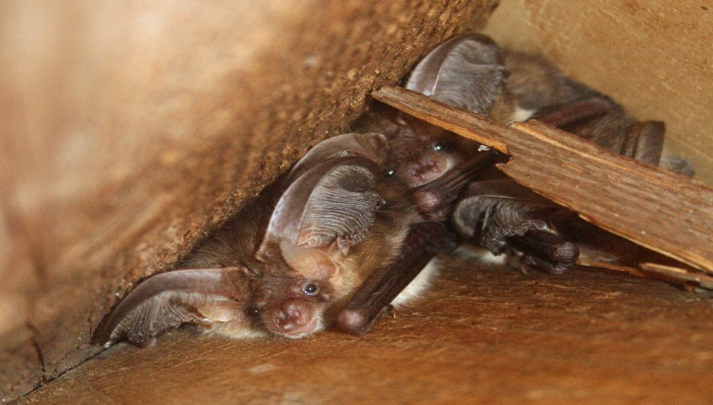
Some works which would be illegal can be carried out under licence. SNH (Scottish Natural Heritage) have issued Aberdeenshire Council Housing Service with a Bat Licence. This allows staff and contractors working under the Licence to disturb and take bats and destroy bat roosts under certain conditions. It is an offence to fail to comply with the conditions of the SNH Bat Licence.

Bats Like Buildings - In summer they roost: -
  - In constantly heated buildings – sheltered housing is often favoured
  - In houses/flats in warm parts of buildings, in roof space, loft and ceiling voids, under flat roof covering and hanging tiles etc.
Access points into buildings can be under loose tiles or ridge tiles; gaps around chimneys, vent pipes and dormer windows; under soffit boxes and barge boards etc. An access hole can be as little as 20mm by 15mm.
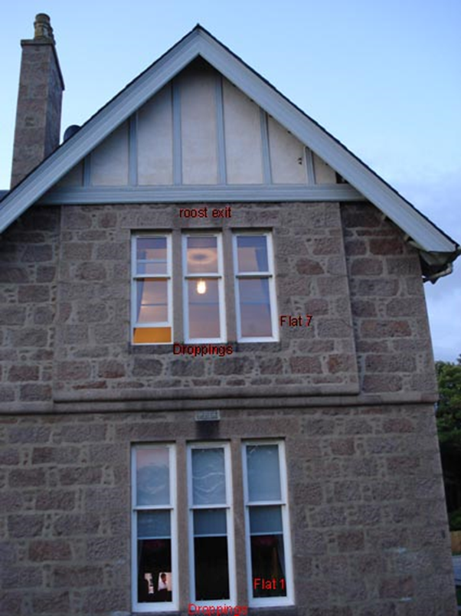 | 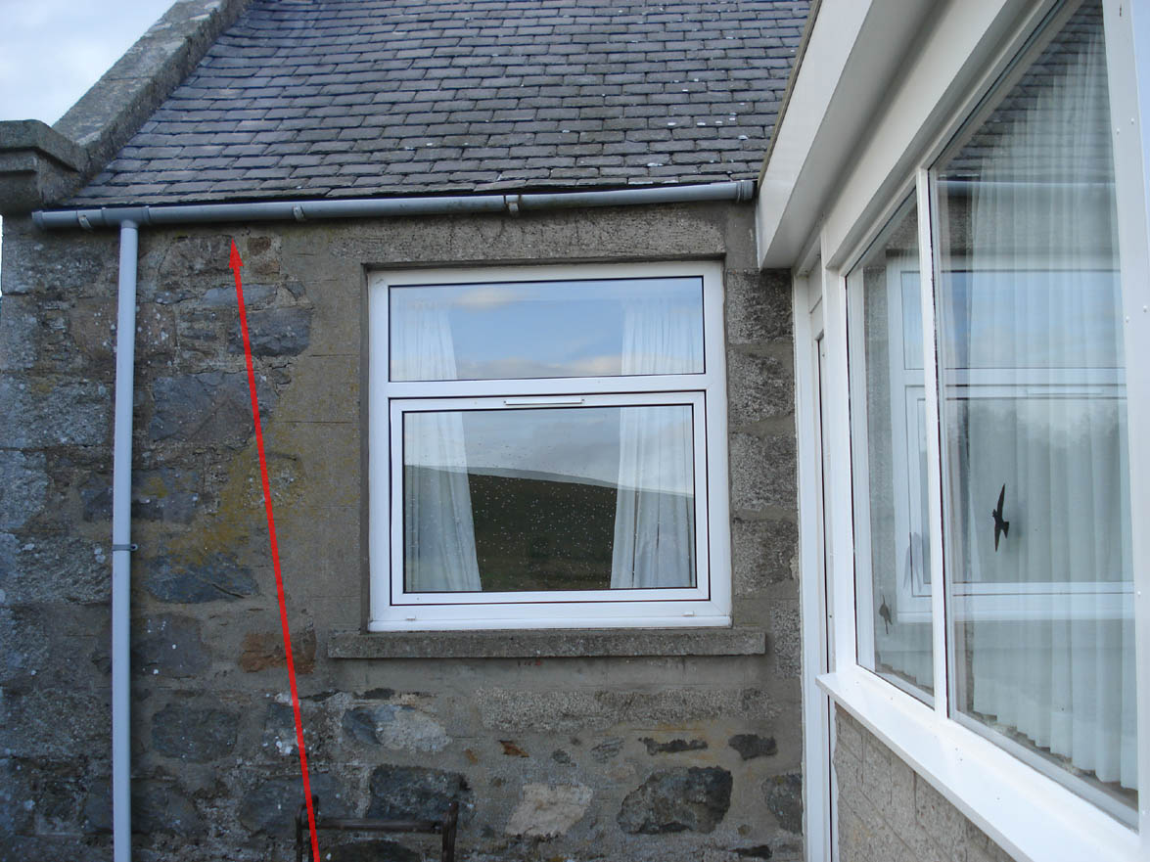 | 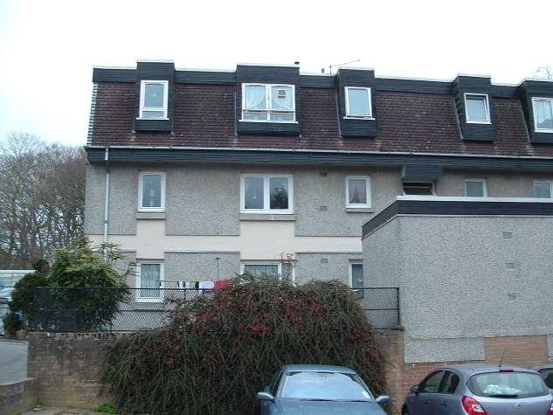
Under barage boards | Gaps under gutter | Under hanging tiles and around dormer windows
What is covered by the Licence?
- Works to properties classified by Aberdeenshire Council (desk based assessment) as Negligible Roost Potential and classified as Low Roost Potential following External Preliminary Roost Assessment (PRA) undertaken by a licenced bat surveyor.
- Works to properties classified by PRA as having Moderate and High Roost Potential where activity survey has confirmed fewer than 5 bats of licenced species are present.

What is NOT covered by the Licence?

- Works to all Aberdeenshire Council sheltered housing main complex buildings, (NB- sheltered linked cottages not forming part of the main complex building are included in the Licence).
- Works to properties classified as having Moderate or High roost potential by PRA which, following activity survey, have been found to have a roost of more than 5 bats.

What you need to consider and what action should be taken for each Housing property is outlined in the ‘Bat Protection Process Table’ which covers all Housing works. All categories highlighted in table below also have ‘bat flag’ alert on Northgate.

Northgate ‘Bat Flags’
The Northgate system will show a ‘bat flag’ alert for properties requiring further survey work or discussion with an Environment Planner before you start any works. For ALL properties that DO NOT have a ‘bat flag’ alert on Northgate work can proceed following the conditions of the SNH Bat Licence.

All properties on the Council's Housing database, (Omega) are categorised to determine their bat status. As new properties are acquired, built or leased, (for which the Council has an ongoing repairing/ maintenance liability), these addresses will also be categorised to determine their bat status. ‘EP’ refers to Aberdeenshire Council Environment Planners. (emma.williams@aberdeenshire.gov.uk and james.davidson@aberdeenshire.gov.uk). Note that bat activity surveys are seasonal and planning ahead is essential to avoid delay. This table should be used together with the Bat Tool Box Talk and the SNH Bat Licence for Housing 2018-2019 documents.

Bat Protection Process Table for ALL Housing Works v9 6-2018
Bat Status on Omega | Further Bat Survey Required? | Contractor Action: Survey Stage | Covered by  SNH Bat Licence? | Contractor Action: Pre Works Stage | Contractor Action During EXTERNAL Works (numbers refer to actions listed in document ‘Management of Aberdeenshire Council Housing Stock in relation to bats’) | Contractor Action During INTERNAL Works (*) | On completion of the Works
Negligible | ✘ | ✘ | ✔ | Undertake Tool Box Talks then all works can be progressed | 2.1 Undertake Pre-works Inspection,  2.2 Work in bat sensitive manner, 'soft strip'(**).  2.4 If finding 5 or less bats use bat kit.  2.5 IMMEDIATELY STOP WORK and take advice from EP if:  - More than 5 bats are found  - Any bats are found between December to February inclusive.  - If any juvenile, (non fury) bats are found | If finding any bats immediately stop works contact EP who will advise. | Pass to housingtechnicalteam  @aberdeenshire.gov.uk email address  - Completed bat surveys  - Bat Licence returns
Low
Negligible-Bats Excluded
Low-Bats Excluded
Moderate-Bats Excluded
Moderate-Bat Survey Done-No Bats
High-Bats Excluded
High-Bat Survey Done-No Bats
Moderate  -Survey Req. for Ext. Works | ✔ | If NO existing bat survey - Get activity survey done, FOR EXTERNAL WORKS ONLY. Instruct survey from list of bat surveyors to be contacted. | ✔  if less than 5 bats found by activity survey | Undertake Tool Box Talks then all works can be progressed | 2.1 Undertake Pre-works Inspection,  2.2 Work in bat sensitive manner, 'soft strip'(**).  2.4 If finding 5 or less bats use bat kit.  2.5 IMMEDIATELY STOP WORK and take advice from EP if:  - More than 5 bats are found  - Any bats are found between December to February inclusive.  - If any juvenile, (non fury) bats are found | If finding any bats immediately stop works contact EP who will advise. | Pass to housingtechnicalteam  @aberdeenshire.gov.uk email address  - Completed bat surveys  - Bat Licence returns
High
-Survey Req. for Ext. Works
 |  |  | ✘  if more than 5 bats found by activity survey | Apply for separate Licence to SNH if needed (EP can give further advice). | Follow conditions of any separate Licence that was needed. | Follow conditions of any separate Licence that was needed. | Pass to housingtechnicalteam  @aberdeenshire.gov.uk email address  - Completed bat surveys
Bat Status on Omega | Further Bat Survey Required? | Contractor Action: Survey Stage | Covered by  SNH Bat Licence? | Contractor Action: Pre Works Stage | Contractor Action During EXTERNAL Works (numbers refer to actions listed in document ‘Management of Aberdeenshire Council Housing Stock in relation to bats’) | Contractor Action During INTERNAL Works (*) | On completion of the Works
Moderate-Bat Survey Done-Bats Present | ✘ | If existing survey available - contact EP who will advise. | To be determined
High-Bat Survey Done-Bats Present
Sheltered | Unknown | For all ‘sheltered’ Omega categories – for all external works, or internal works that will intrude into roof voids, or ceiling voids in communal areas, (e.g. boiler & lift upgrades, re-wiring or sprinkler systems), speak to EP to determine likely impact of works. Get activity survey done if needed. | ✘ | - Apply for separate Licence to SNH if needed (EP can give further advise) OR  - If no bats are found at activity survey or no survey is needed, then follow the recommendations of EP. | If separate Licence was need then follow conditions of the Licence.  If no Licence was needed then if finding any bats immediately stop works, contact EP who will advise if bat surveyor or SNH need to be contacted. | If separate Licence was needed then follow conditions of the Licence.  If no Licence was needed then if finding any bats immediately stop works, contact EP who will advise if bat surveyor or SNH need to be contacted. | Pass to housingtechnicalteam  @aberdeenshire.gov.uk email address  - Completed bat surveys
Sheltered-Bat Survey Done-No Bats

Sheltered-Bat Survey Done-Bats Present

Sheltered-Bats Excluded
PRA Required  (External Provisional Roost Assessment) | ✔ | Speak to EP to see if activity survey is needed. | To be determined

(*) Internal Works | (**) Soft Strip | Demolition Works
Kitchens, bathrooms, heating, rewiring, door entry systems, window, door upgrades and Internal Wall Insulation (IWI). | External Wall insulation (EWI), dormers (pitching of flat roofs), porches (pitching of flat roofs), Photovoltaic Roof Panels (PVs), Roof Cover Replacement and roof lights removal or replacement. | Not cover by SNH Bat Licence. Consult with EP in every case other than those with 'negligible' status on Omega.

The bat status on Omega will display the following Northgate ‘bat flag’ alerts:

'Bat Roost Potential' Field on Omega | 3 Northgate Flags
PRA Required | BATS - Bat Roost Potential - SEETABLE
Sheltered | BATS - Bat Roost Potential - SEETABLE
Moderate-Survey Req. for Ext. Works | BATS - Bat Roost Potential - EXTWRKSURVEY
High-Survey Req. for Ext. Works | BATS - Bat Roost Potential - EXTWRKSURVEY
Moderate-Bat Survey Done-Bats Present | BATS - Bat Roost Potential - PRESENT
High-Bat Survey Done-Bats Present | BATS - Bat Roost Potential - PRESENT
Sheltered-Bat Survey Done-Bats Present | BATS - Bat Roost Potential - PRESENT

Contractor Action to meet Licence Conditions
Pre-works inspection - The Licence requires us to carry out a pre-works inspection of the work area before starting work. Look out for: -

Droppings, smell and staining
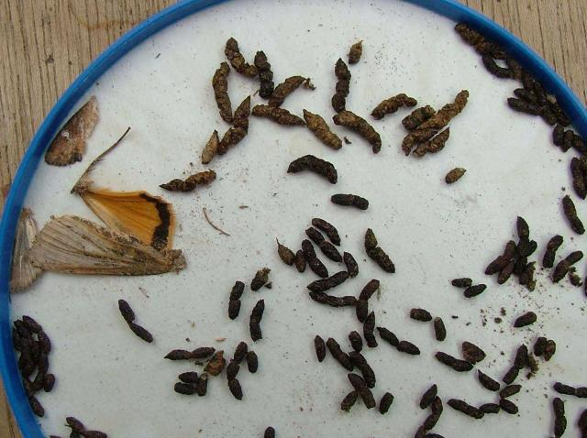 | Bat droppings are found underneath a roost (in roof space for example) and below the access point into a building (this might be on a window ledge for example). Droppings are dry and crumble to dust when pressed between your fingers (make sure you wear gloves) | 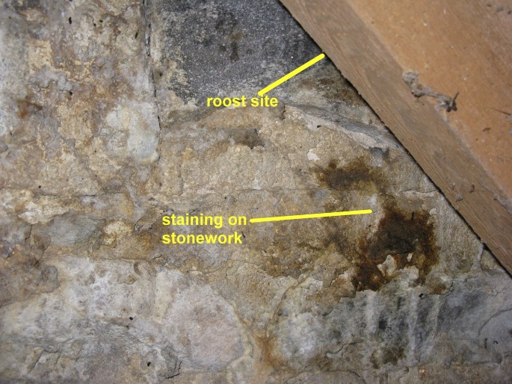 | Bat urine can cause staining on stonework and metal surfaces.
If heavy signs of use by bat are found in a pre-work inspection or at any time during works – STOP IMMEDIATELY and take advice from Aberdeenshire Environment Planners on how to proceed.

Contractor Action to meet Licence Conditions
Soft stripping - The Licence requires us to work in a bat sensitive manner. This includes soft-stripping by-hand using hand tools and checking materials for bats before discarding.
Soft stripping should be carried out for: -
External Wall Insulation, roof cover replacement, roof light removal or replacement, works to dormer windows, works to porch roofs, PVs.

Contractor Action to meet Licence Conditions
Any bat found and removed should be recorded on the Bat Licence Return proforma and returned to the Manager at the end of the works.
Licence return proforma - SNH Bat Licence - record of works affecting bats
Return completed by : -
Date (dd/mm/yy) | Location - Property Address | Number of bats present | Brief details of works being carried out (i.e. removal of slates) | Details of action taken (i.e. bat removed to container and release as per condition etc)
This licence return must be submitted to the Housing Technical Team Group email address - housingtechnicalteam@aberdeenshire.gov.uk

Please note that failure to comply with the condition on the SNH Bat Licence is an offence and that reporting of any bats found is required as a condition

Contractor Action - What to do if you find bats covered by the Licence
If you find 5 bats or less in a property covered by the SNH Bat Licence you can transfer, contain and release the bat/s as follows
To handle any bat WEAR GLOVES due to the small risk of a type of rabies.
To contain a bat you will need your ‘bat kit’ which is a shoe box (or similar container), with holes punched in the lid, a cloth or tea towel, a plastic bottle cap (milk bottle tops are perfect)
1. Contain the bat like a spider, by placing a box on top of it and sliding a piece of card underneath or cover the bat with a cloth/tea towel and carefully scoop it up and place it in the box. (You should not handle the bat with bare hands.)
2. Put a tea towel or soft cloth in the box for the bat to hide in.
3. Put in a small, shallow container e.g. a plastic milk bottle top with a few drops of water (not enough for the bat to drown in). Make sure the water is topped up regularly.
4. Keep the bat indoors somewhere quiet and dark.
5. Place the container on a raised area outside at dusk to allow the bat to disperse (remove the lid). A bat should never be released during the day and should only be release if fit and healthy.
6. If you think the bat is injured in anyway call the Bat Conservation Trust Bat Helpline on 0345 1300 228 for further advice and a bat rehabilitator will be able to advise.

Contractor Action - What to do if you find bats not covered by the Licence
You should immediately stop work and ask for advice if: -
- A roost site with more than 5 bats is found.
- Any bats are found during the winter (December-February inclusive) when bats are hibernating (this period could extend in either direction if weather is particularly cold).
- Any juvenile bats are found (bats that do not have a fury body).

If more than 5 bats are found or if uncertain of what to do with any bat contact Aberdeenshire Environment Planners for initial advice on immediate action and further contacts for Bat Surveyors as needed
Emma Williams – emma.williams@aberdeenshire.gov.uk 01467539220
James Davidson – james.davidson@aberdeenshire.gov.uk 01467537669
SNH Licensing - licensing@snh.gov.uk 01463725364
For Injured Bat Call - Bat Conservation Trust Bat Helpline on 0345 1300 228

