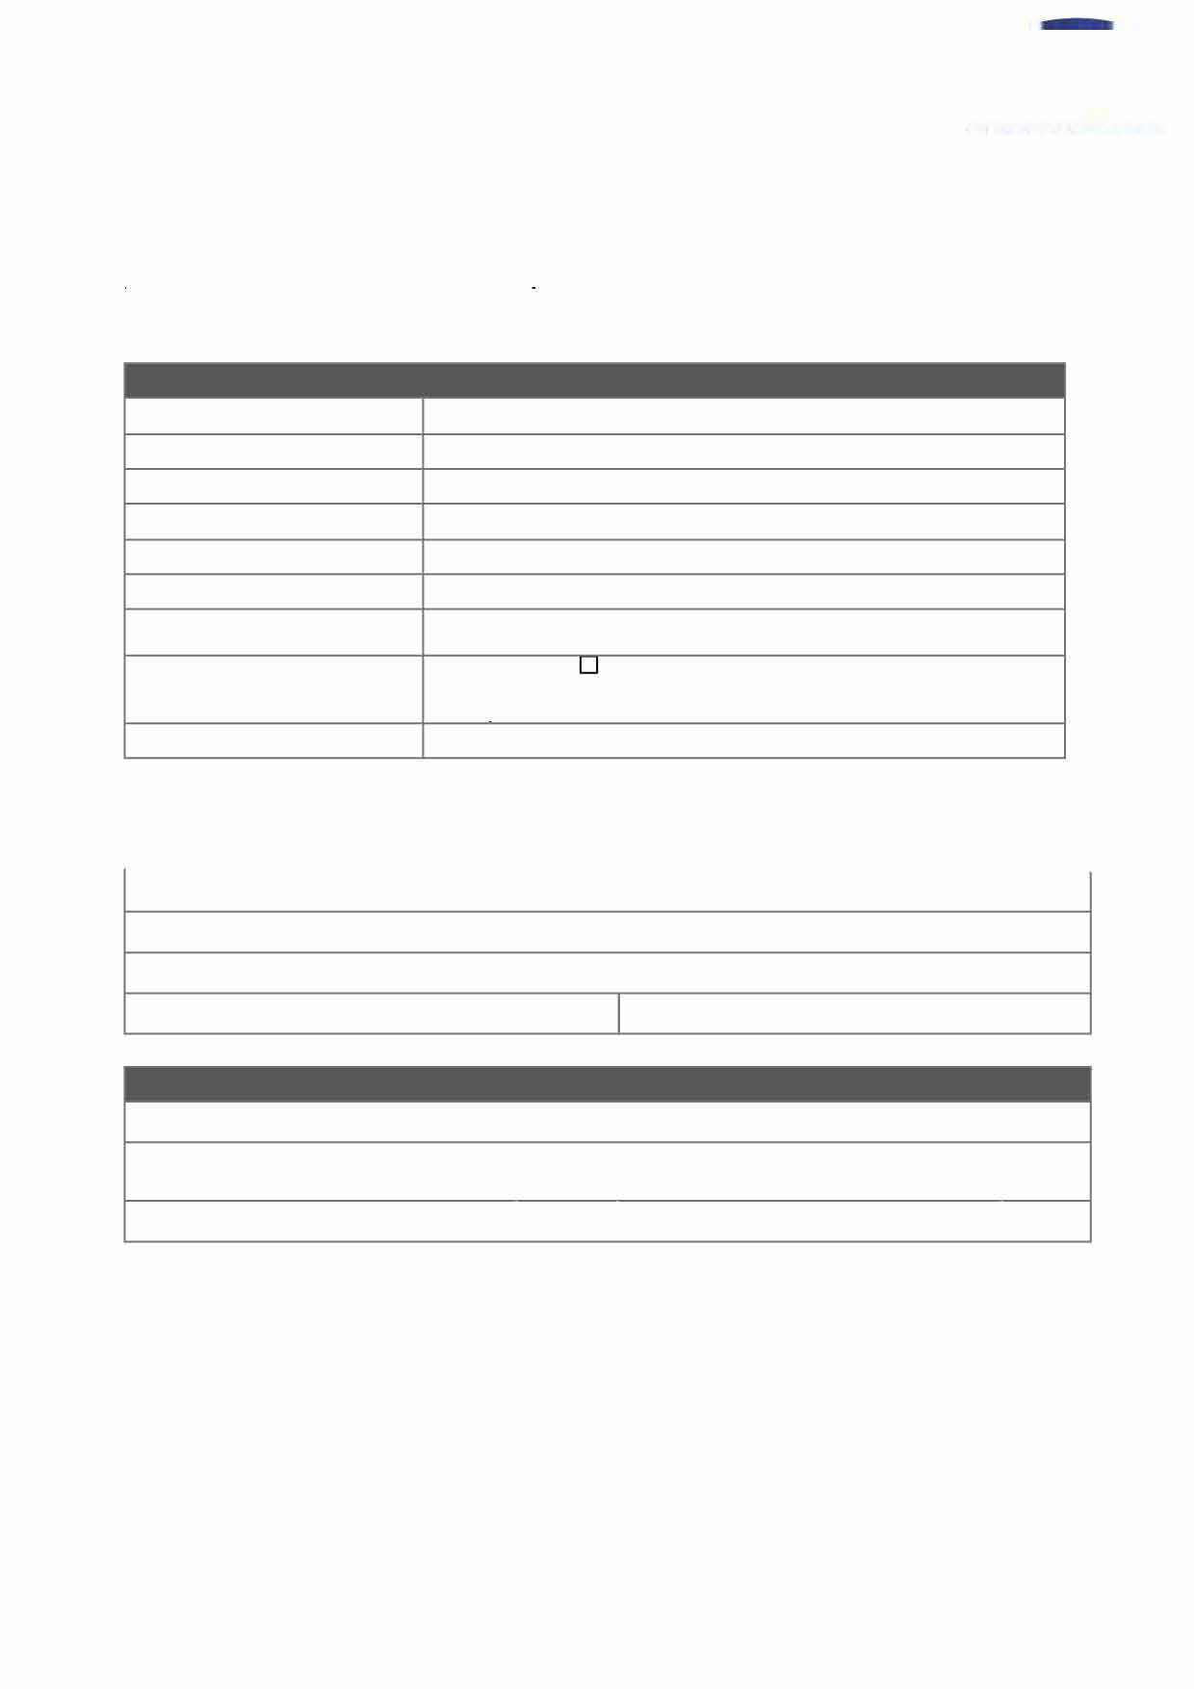

**CONFIDENTIAL**

**Needle Stick Injury Referral -**

**Aberdeenshire**

**Council**

All areas of this form must be completed.

It is important the Occupational Health Clinician is in possession.

of

all the relevant facts.

The contents of

this form will be discussed during your employee's appointment.

To m

make an appointment, please complete this form, and send it to:

A

B

Z

.

A

berdeenshireCouncil

@

tachealthcare.com

To contact the b

booking team with any queries please phone

01224 669070

**Referrer,**

**Company Name and Address Details**

Referrer Name:

Company

*I*

Employer Name:

Company Address:

Position in Organisation:

Contact Tel. Number:

E-mail Address:

Preferred Date of

Appointment:

Needle Stick

**Type of Referral**

Sharps

□

Bite Injury

□

**Cost Code**

NONCORE49

-

Needle Stick Injury

Address:

E-mail Address:

Daytime Telephone Number:

**Job Title**

Job litle:

Location of Post (address or site location):

Full lime (Please tick)

Printed copies are UNCON1ROLLED,

It is the user's responsibility to verify

printed material against the controlled document.

I

□

Mobile Number:

I

Part lime {Please tick)

I

□

Needle Stick Sharps and Bites MRF (ISOS)

OCH -

FRM -

040

Rev: 1, Issue: 29/11/2018, Page 1 of 2

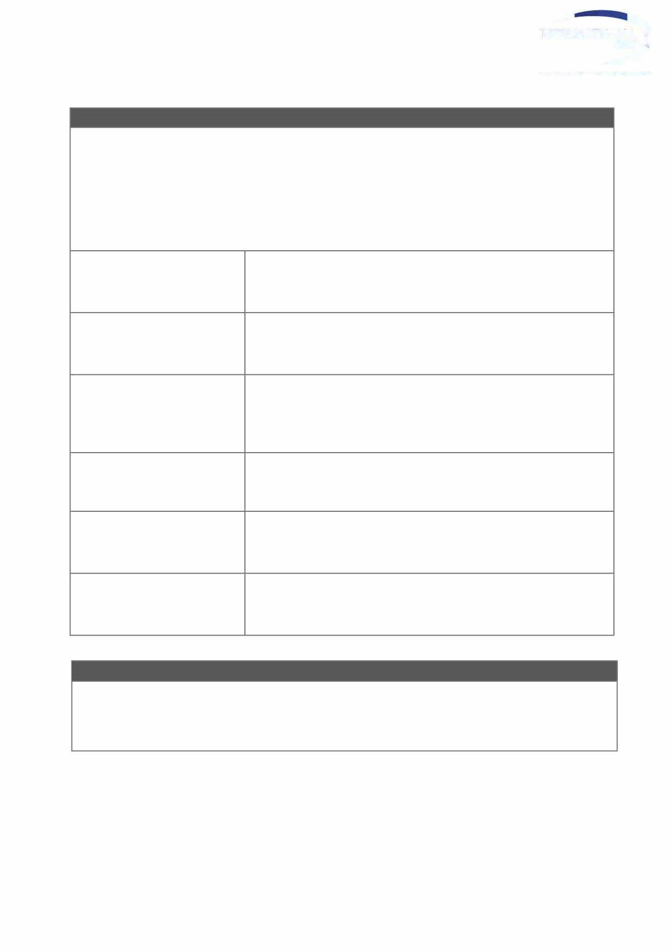

**CONFIDENTIAL**

**Occupational**

**Health Service Referral**

**Reason for Referral (please X as appropriate)**

Please provide details:

lime and Location of injury:

History of Injury:

Was basic first aid carried out in

accordance with company's

needle stick, sharps and bite

injuries policy?

Hep B status

(

if known)

How long after the incident was

it reported?

Have any nearby Health Care

facilities been approached?

**I**

**Next Step**

Should the clinician advise that follow-up any vaccinations or bloods are recommended in future, the

patient will be informed at their appointment and the ad min team will contact client to arrange a follow-up

appointment.

Printed copies are UNCON1ROLLED,

It is the user's responsibility to verify

printed material against the controlled document.

Needle Stick Sharps and Bites MRF (ISOS)

OCH -

FRM -

040

Rev: 1, Issue: 29/11/2018, Page 2 of 2

