Microsoft Office 2016 Installation Instructions
For Windows PCs:
Depending on your browser, click Run (in Edge or Internet Explorer), Setup (in Chrome), or Save File (in Firefox).
If you see the User Account Control prompt that says, Do you want to allow this app to make changes to your device?, click Yes.
The installation will begin.
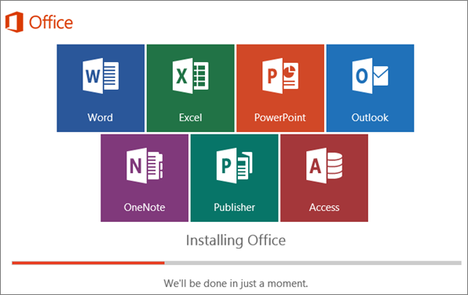

When you see You're all set! Office is installed now an animation plays to show you where to find Office applications on your computer. The time taken will depend on the speed of your home internet.
Follow the instructions in the window, for example Click Start > All Apps to see where your apps are, and select Close.
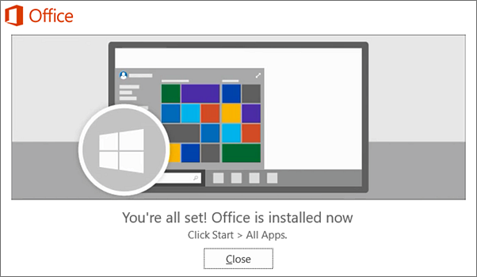

Activating Microsoft Office
Start using an Office application right away by opening any app such as Word or Excel. Can't find Office after installing?
In most cases, Office is activated once you start an application and after you click Accept to agree to the License terms. Please note, the license will show this linked to your work email address.
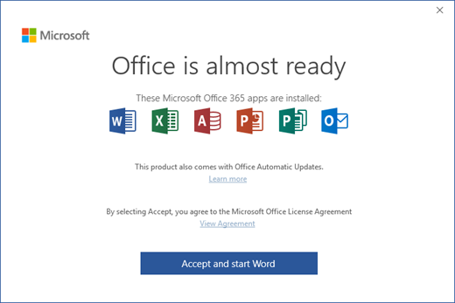
Microsoft Office may activate automatically but you may see the Microsoft Office Activation Wizard. If so, follow the prompts.
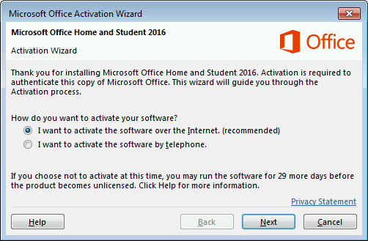
If you need activation help, see Activate Office 365, Office 2016

Installation or sign in issues?
If you're having installation issue such as Office taking too long to install, try Need help? for a list of common issues.

For Apple Mac users:
Once the download has completed, open Finder, go to Downloads, and double-click Microsoft_Office_2016_Installer.pkg (the name might vary slightly).
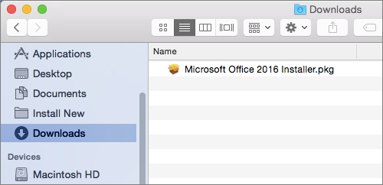
Tip: If you see an error that says the Microsoft_Office_2016_Installer.pkg can't be opened because it is from an unidentified developer, wait 10 seconds and then try double-clicking the installer package again. If you're stuck at the Verifying…. progress bar, close or cancel the progress bar and try again.
On the first installation screen, select Continue to begin the installation process.
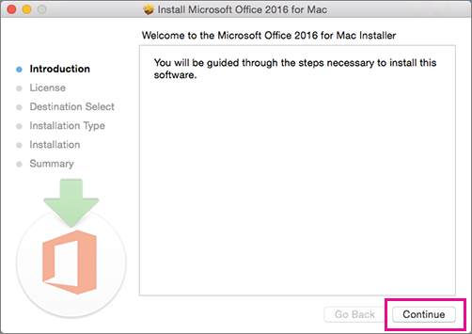
- Review the software license agreement, and then click Continue
- Select Agree to agree to the terms of the software license agreement
- Choose how you want to install Office and click Continue
- Review the disk space requirements or change your install location, and then click Install
Note: If you want to only install specific Office apps and not the entire suite, click the Customize button and uncheck the programs you don't want.
- Enter your Mac login password, if prompted, and then click Install Software (This is the password that you use to log in to your Mac)
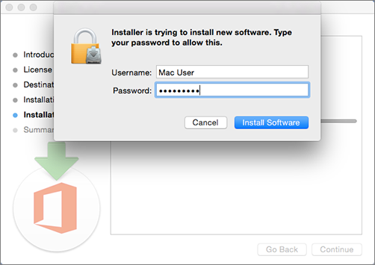
- Click Close when the installation is finished. If Office installation fails, see What to try if you can't install or activate Office 2016 for Mac.
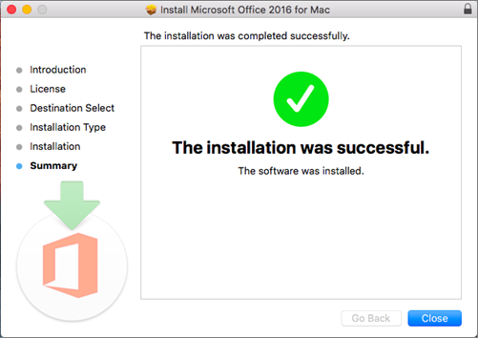

Step 3: Launch an Office for Mac app and start the activation process
Click the Launchpad icon in the Dock to display all of your apps
Click the Microsoft Word icon in the Launchpad
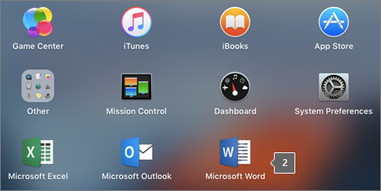
The What's New window opens automatically when you launch Word. To activate, click Get Started. If you need help activating Office, see Activate Office 2016 for Mac. If Office activation fails, see What to try if you can't install or activate Office 2016 for Mac using Office 365 for business.
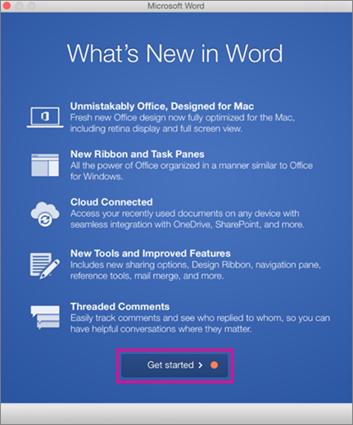
Installation notes
Can I install Office 2016 for Mac and Office for Mac 2011 on the same computer?
Yes, you can install and use Office 2016 for Mac and Office for Mac 2011 at the same time but we recommend you uninstall Office for Mac 2011 before you install the new version just to prevent any confusion.
To uninstall Office for Mac 2011, follow the steps in Uninstall Office 2011 for Mac.
How do I pin the Office app icons to the dock?
- Go to Finder > Applications and open the Office app you want
- In the Dock, Control+click or right-click the app icon and choose Options > Keep in Dock

